**TASK 1**

**Aim:** To simulate the circuits and find voltages across resistors and currents through the source and resistances.

Date: 02/08/2021 Exp. 1 Study of Measuring, Testing, Power Supply Instruments and Bread Board



**Software/Hardware Components used:** LTSpice, 3 Resistors, 1 Voltmeter, Ground, Wire

**Expression:**

Voltage (V) = Current (I) *Resistance (R)

**Circuits and Plots:**

**Circuit 1**

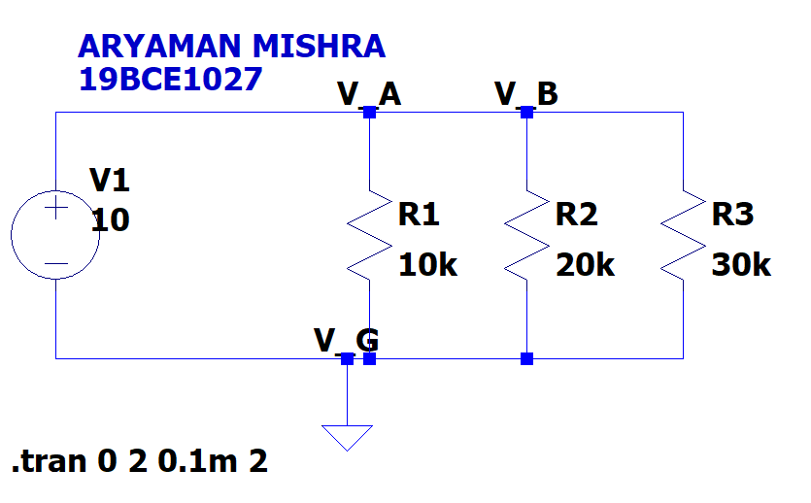

**Plot 1**

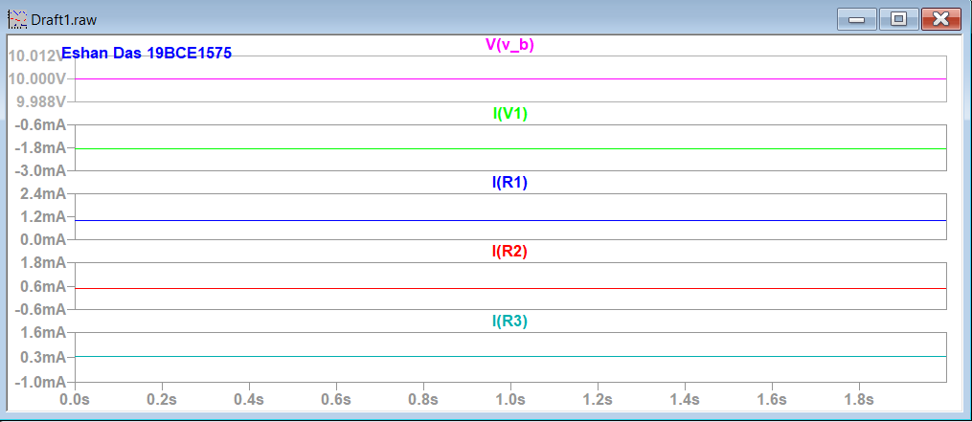

**Circuit 2**

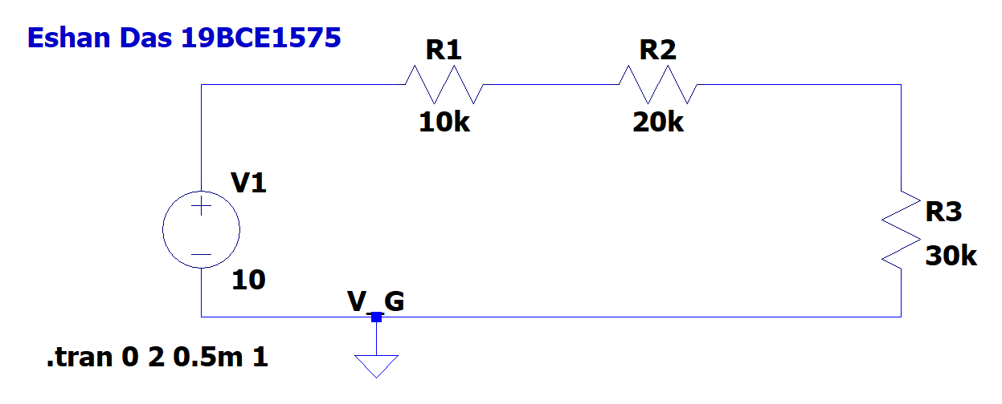

**Plot 2**

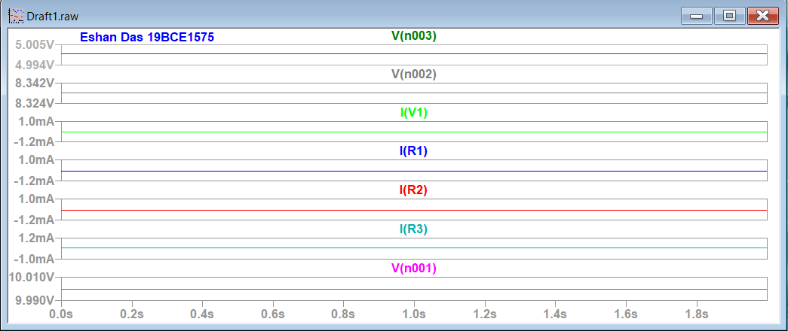

**INPUTS AND OUTPUTS:**

**Inputs**

|  |  |
| --- | --- |
| **Components Used** | **Input Value** |
| V1 | 10V |
| R1 | 10K Ohm |
| R2 | 20K Ohm |
| R3 | 30K Ohm |

**OUTPUTS (Circuit 1)**

|  |  |
| --- | --- |
| **Node** | **Resultant Value** |
| I(R1) | 1mA |
| I(R2) | 0.5mA |
| I(R3) | 0.3mA |
| I(V1) | 1.83mA |
| V(v_b) Through all resistors | 10V |

**OUTPUTS (Circuit 2)**

|  |  |
| --- | --- |
| **Node** | **Resultant Value** |
| I(R1) | 0.16mA |
| I(R2) | 0.16mA |
| I(R3) | 0.16mA |
| I(V1) | 0.16mA |
| V(n001) | 1.6V |
| V(n002) | 3.3V |
| V(n003) | 5V |

**Conclusion:**Hence we successfully simulate the given circuits and find out the accurate voltage across the resistors and the current through the sources and resistors.

**TASK 2**

**Aim:** To find color code of resistors (4 band system)

**Expression:**

**1st: 1st Digit  
2nd : 2nd Digit  
3rd : Multiplier  
4th: Tolerance**

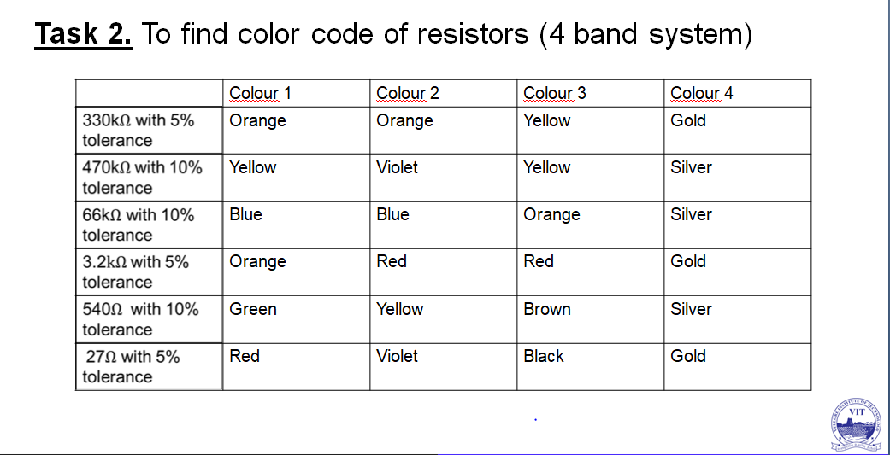

**TASK 3**

**Aim:** To simulate low pass filter (Capacitance)

**Software/Hardware Components used:** LTSpice, 1Resistor, 1 Voltmeter, 1 Capacitor, Ground, Wire

**Circuits and Plots:**

**Circuit**

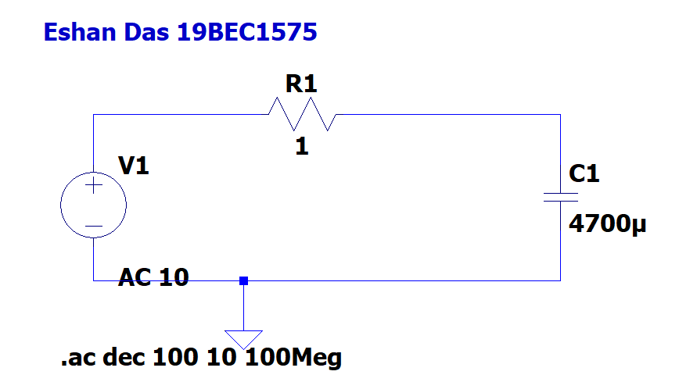

**Plot**

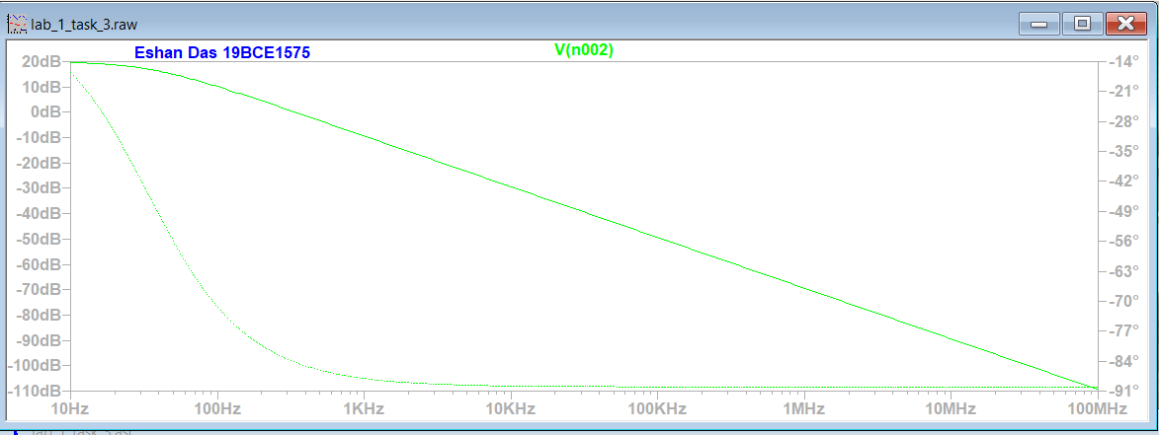

**INPUTS AND OUTPUT:**

**INPUT**

|  |  |
| --- | --- |
| **Components Used** | **Value** |
| V1 | AC Amplitude: 10  Type of Sweep: Decade  Number of points per decade: 100  Start Frequency: 10  Stop Frequency: 100 Meg |
| R1 | 1 Ohm |
| C1 | 4700 micrometer |

**OUTPUT**

|  |  |
| --- | --- |
| **NODE** | **Value** |
| V(n002) | 20 to (-110) dB, 10 Hz to 100MHz |

**Conclusion:** Hence we are able to simulate the circuit to show low pass filter in a capacitor.

**TASK 4**

**Aim:** To simulate low pass filter (Inductance)

**Software/Hardware Components used:** LTSpice, 1 Resistor, 1 Voltmeter, 1 Inductor, Ground, Wire

**Circuits and Plots:**

**Circuit**

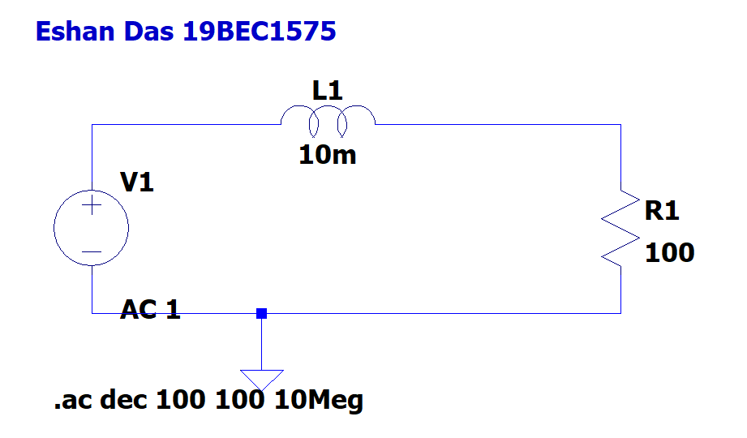

**Plot**

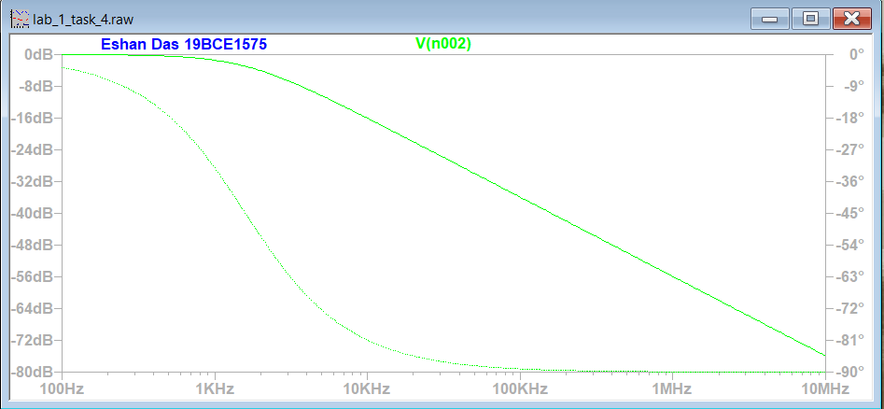

**INPUTS AND OUTPUT:**

**INPUT**

|  |  |
| --- | --- |
| **Components Used** | **Value** |
| V1 | AC Amplitude: 1  Type of Sweep: Decade  Number of points per decade: 100  Start Frequency: 100  Stop Frequency: 10 Meg |
| R1 | 100 Ohm |
| L1 | 10 m |

**OUTPUT**

|  |  |
| --- | --- |
| **NODE** | **Value** |
| V(n002) | 0 to (-80) dB, 100Hz to 10MHz |

**Conclusion:** Hence we are able to simulate the circuit to show low pass filter in aninductor.

**TASK 5**

**Aim:** To find the total resistance of the circuit seen from the source. (Through formula and with V/I).

**Circuit and Expressions:**

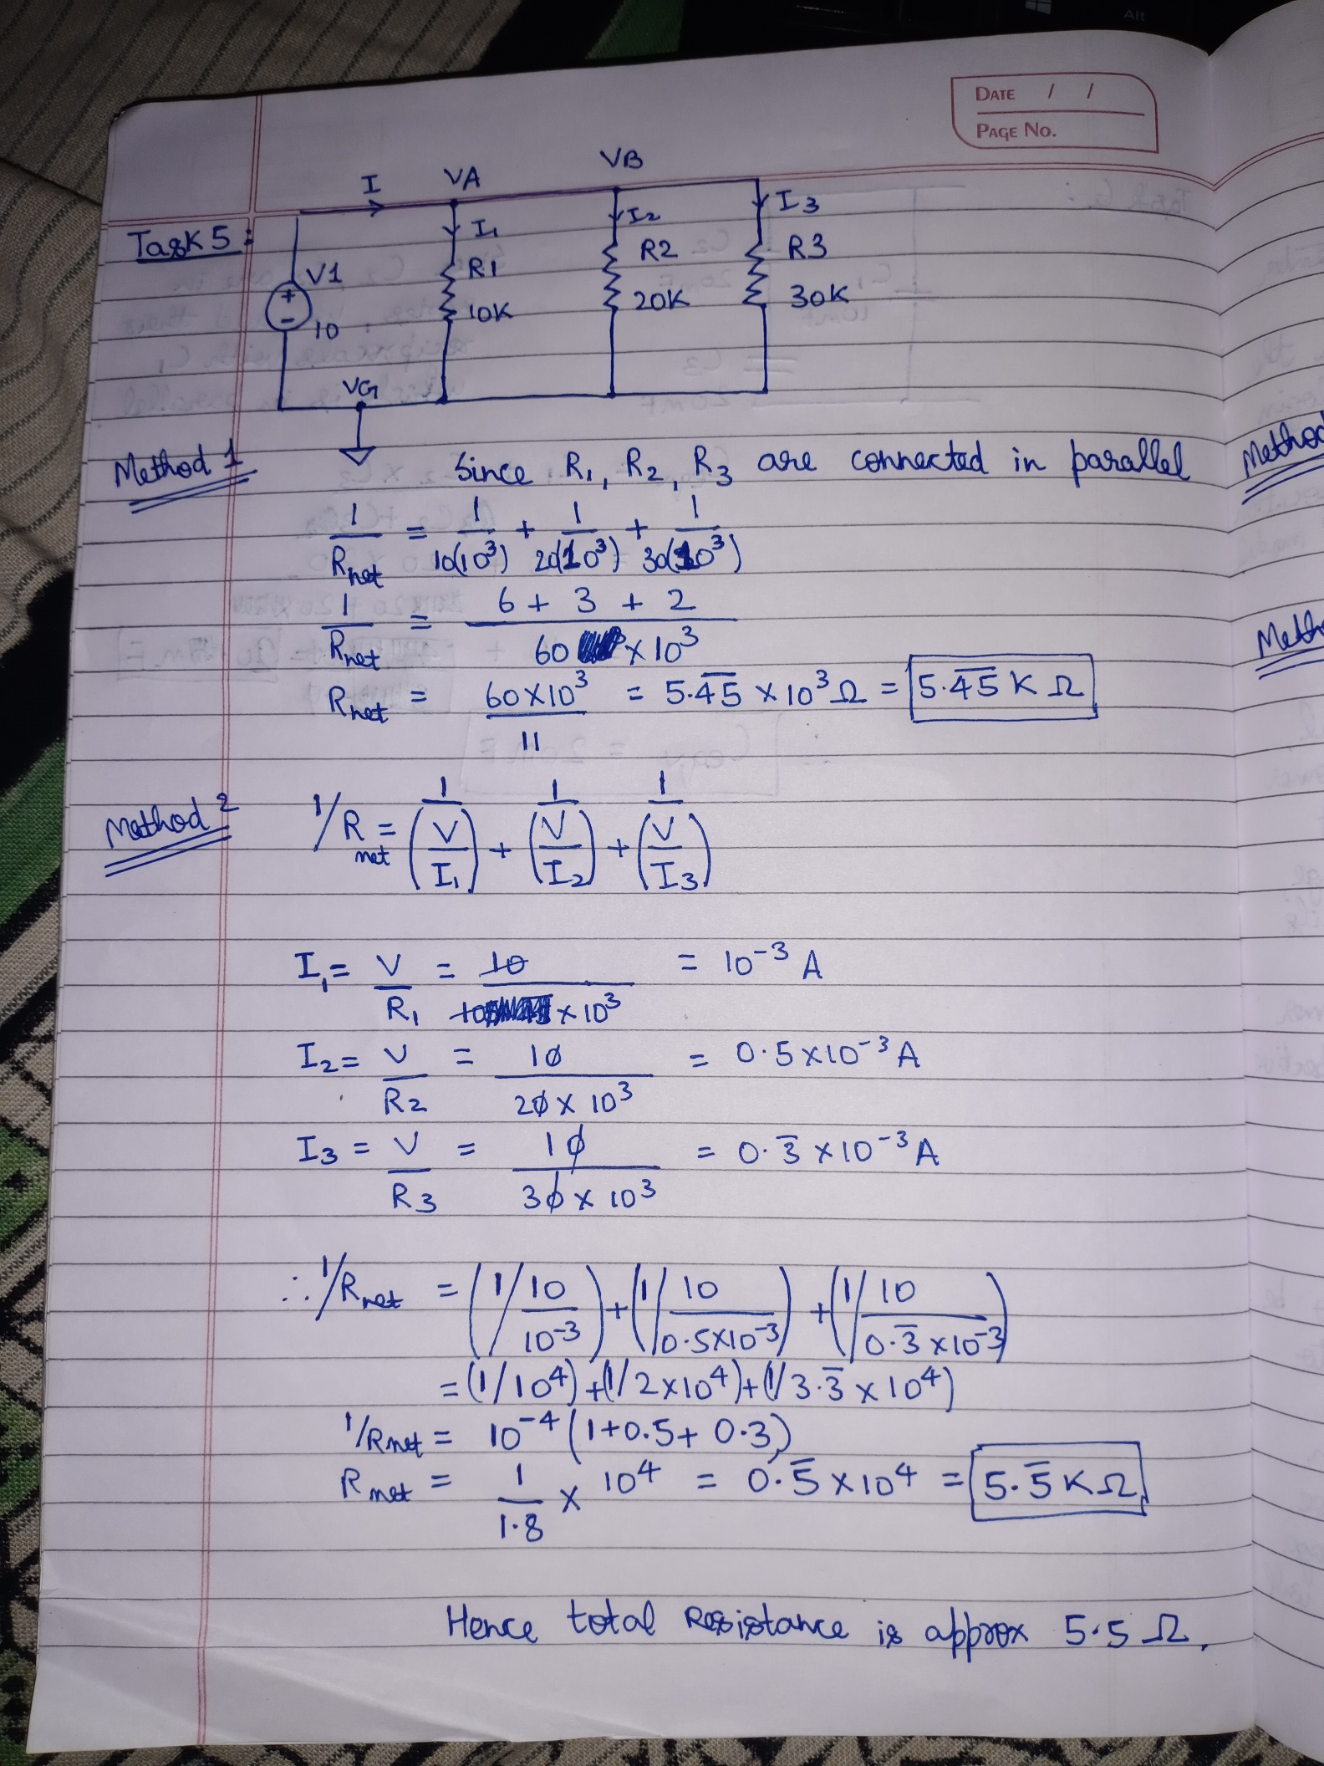

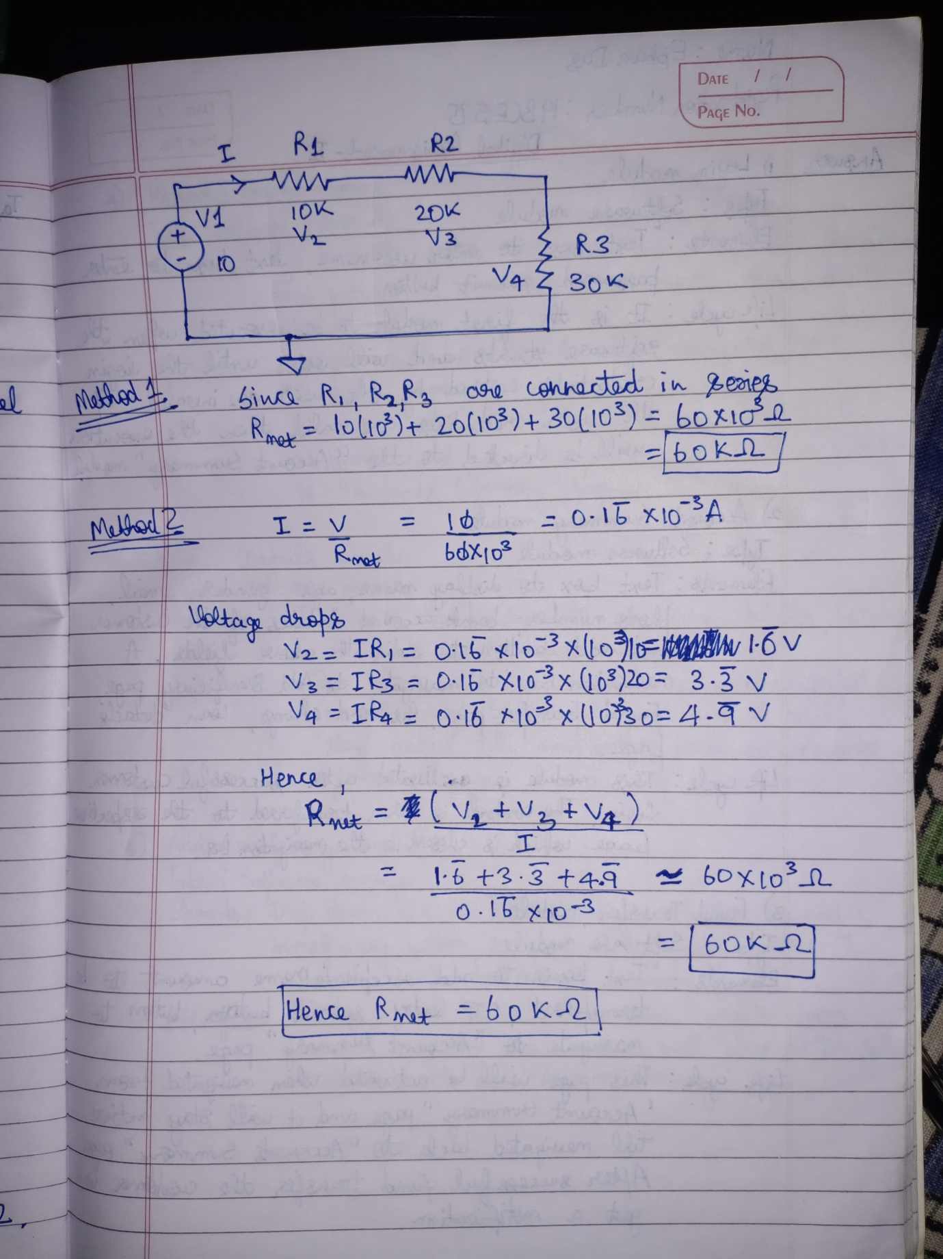

**Conclusion:** Hence the net resistance of circuit 1 is 5.5 K ohm and circuit 2 is 60 K ohm.

**TASK 6**

**Aim:** To find total capacitance of the circuit.

**Circuit and Expressions:**

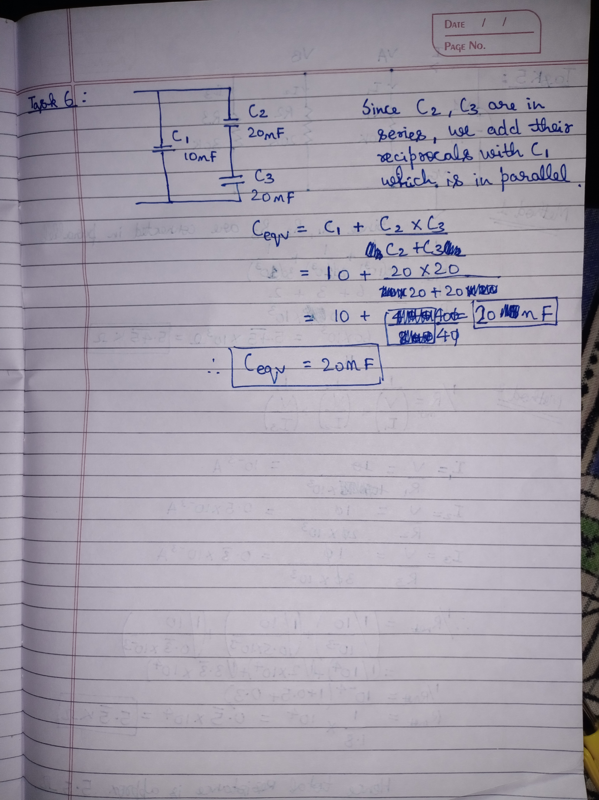

**Conclusion:** Hence the net capacitance of circuit is 20nF.

**TASK 7**

**Aim:** To find total inductance of the circuit.

**Circuit and Expressions:**

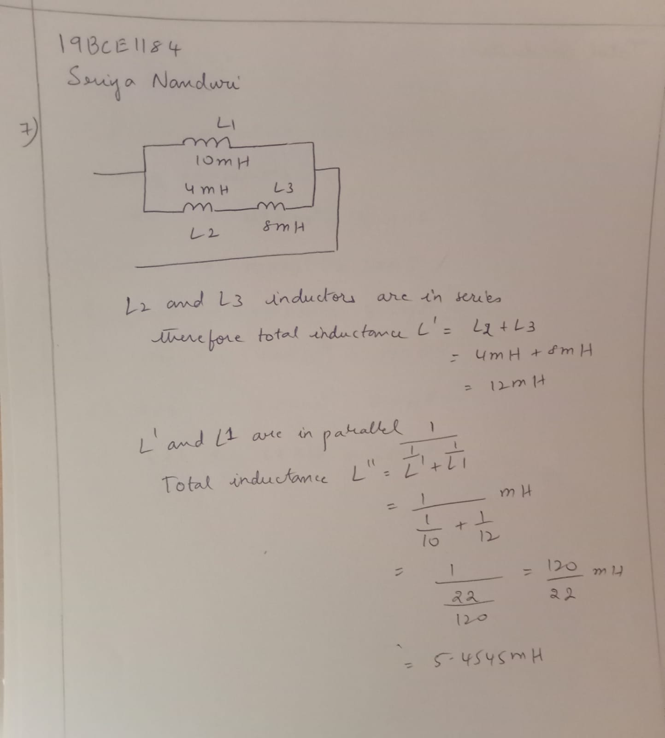

**Conclusion:** The net inductance of the circuit is 5.45mH.

**TASK 8**

**Aim:** To find the capacitance valueswith codes.

**Circuit and Expressions:**

